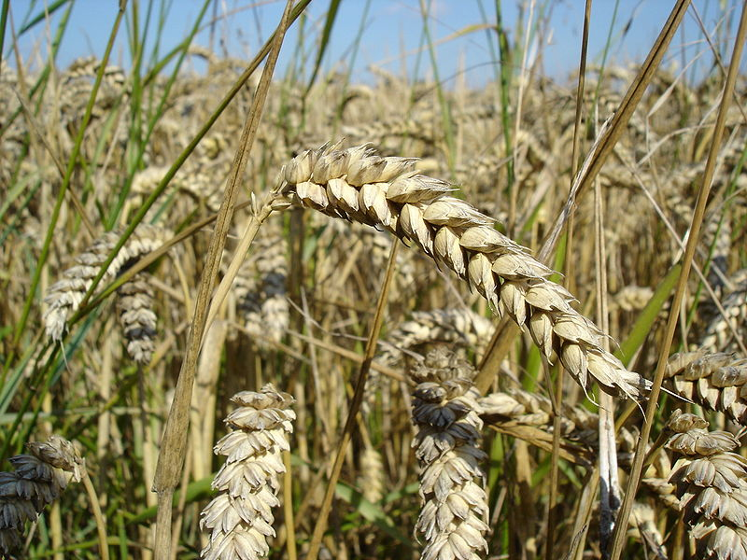World History – Unit One – “Food First”
Vocabulary Terms
1. pre history:
2. historian:
3. artifact:
4. archaeology:
5. anthropology:
6. technology:
7. culture:
8. hominid:
9. Homo habilis:
10. Homo erectus:
11. Homo sapiens:
12. agriculture:
13. subsistence:
14. agrarian society:
15. domestication:
16. Paleolithic Period:
17. Neolithic Period:
18. Neolithic Revolution:
19. nomads:
20. hunters and gatherers:
21. resources:
22. job specialization:
23. migration:
24. BCE:
25. CE:
26. cultural diffusion:
27. class system:
28. stratification:
29. urbanization:
30. surplus:
31. barter economy:
32. traditional economy:
33. civilization:
34. polytheistic:
35. artisan:

