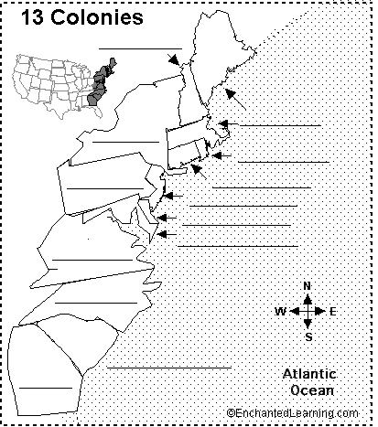

American Government – Civics

- Label the original 13 colonies by name.
- Shade the original 13 colonies as:

CHARTER ROYAL PROPRIETARY

