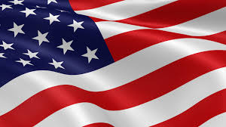

Design a Minor Political Party!

- Statement of Purpose

- Party Type

- Campaign Slogan

- Party Symbol

- Detailed Platform

- Design a Power Point or Google Slide Presentation sharing #1 – 5 from the above list!

- Have fun!

