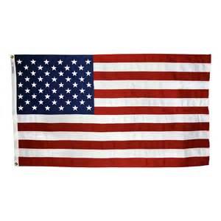
Introductory Lesson – What is Government?
Chapter 1: Principles of Government
Section 1: Government and the State, pp.4-11
Mrs. Collins, Room 106

Task One: Text to Speech

Government is the institution through which a society makes and enforces its public policies. Government is made up of those people who exercise its powers, all those who have authority and control over people.

~Page 4, Magruder’s American Government

http://www.text2speech.org/

Task Two: LinoIt

What do you think government is? Go to the link below to share your response!

http://linoit.com/users/miriamcollins/canvases/Civics%20-%20What%20is%20Government%3F%20

Task Three: Quizlet

Essential Vocabulary Words: (from Chapter 1, Section 1)

- Government
- Public policy
- Legislative power
- Executive power
- Judicial power
- Constitution
- Democracy
- Dictatorship
- State
- Sovereign

This link will take you to the “What is government?” Quizlet – flash card review for this section.

https://quizlet.com/_3kylpa

Task Four: School House Rock – YouTube

The Purpose of Government – the text draws from the Preamble to the Constitution to spell out why and for what reason people need government. An easy way to remember all of these reasons is to go to the following link for School House Rock!

https://video.search.yahoo.com/yhs/search?fr=yhs-mozilla-003&hsimp=yhs-003&hspart=mozilla&p=school+house+rock+preamble#id=2&vid=c3d7c14314e5e96bb8731c9cb8c16a4a&action=click

(Note: form a more perfect union, establish justice, insure domestic tranquility, provide for the common defense, promote the general welfare, secure the blessings of liberty)

Task Five: Khan Academy – The Preamble

Khan Academy – Video – the Preamble to the Constitution – explains the history behind creating the US Constitution and whom it serves and why.

https://www.khanacademy.org/partner-content/aspeninstitute/civil-liberties-privacy-constitution/constitution-deals-with-civil-liberties-age-technological-change/v/the-preamble-of-the-us-constitution

