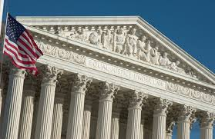
The Supreme Court of the United States
- The Supreme Court is made up of how many Justices?

- Who is the current Chief Justice?

- Who are the Associate Justices?

- Why is the Supreme Court called the “highest court in the land”?

- What is the significance of the case Marbury v. Madison?

- What is the “rule of four” and how does it affect the number of cases the Supreme Court decides?

- How many Justices must agree for a case to be decided?

- Are most Supreme Court cases unanimous? Why/why not?

