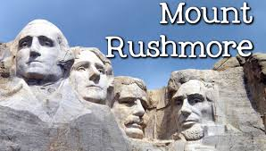

The Executive Branch

- True or False: The President of the United States must be a natural-born citizen per the U.S. Constitution.

- What is the function of the Executive Branch?

- True or False: The U.S. President is one of the most powerful leaders in the world.

- Who are the first five (5) presidents in order of service?

- Who was the sixteenth (16th) President?

- How old must you be to consider becoming the President?

- What is the POTUS?

- Who is the FLOTUS?

- How long must a person live in the U.S. before he/she is able to run for the Presidency?

10.How many presidents have there been since 1789?

